Assignment 3

DSP for Computer Science

- A conjugate symmetric sequence(or function), 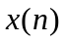 is one where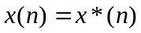, where * represents complex conjugate. Likewise a conjugate antisymmetric sequence is on where 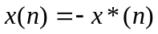. This is a generalization to complex domain of the definitions even and odd symmetric sequences defined for real sequences. Show that a DTFT 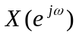can be decomposed into a sum of conjugate symmetric and conjugate antisymmetric functions
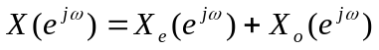. Find 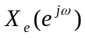 and 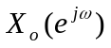. Show your working.
- Write a MATLAB or a software routine to compute the DTFT of any input sequence. Assume all sequences to be causal (starting at x=0). Plot the magnitude and phase response of the sequence
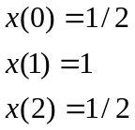
- Consider the function:
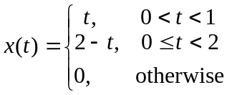
Write the equation for x(2t) and x(t/2). Plot them.
- In MATLAB or a software of your choice, write a routine to sample the three functions in question3. Sample them at the rate of 100 samples/s. Take samples worth 3 seconds. Compute the DTFT for each of them and plot the magnitude response. What can you say about the three magnitude responses?

